**Carbohydrates**

The name carbohydrate is used to desig­nate the large class of compounds that are polyhydroxy aldehydes or ketones. Therefore, carbohydrate means hydrate of carbon.

**Biological importance of carbohydrates:**

• Provide a significant fraction of the energy in the diet of most organisms

•Act as a storage form of energy.

• Serve as structural components of many organisms (cell wall, the exoskeleton of insects).

• Act as constituents of nucleotides (ribose in RNA, deoxyribose in DNA).

**General Structure:**

Carbohydrates con­tain only three elements-carbon, hydrogen, and oxygen. The ratio of hydrogen to oxygen is typically 2: 1 in the molecule. The general structural formula is:

CnH2nOn or Cn(H2O)n (hydrates of Carbon)

• n= number of atoms

**Classification of Carbohydrates:**

According to the number of basic sugar or saccharide units, incorporat­ed in the molecule carbohydrates can be classified into monosaccharides, disaccharides, and polysaccharides. For the most part, the mono and disaccharides are sweet, crystalline solids that are readily solu­ble in water. Polysaccharides are frequently tasteless, insoluble, and amorphous compounds.

**1. Monosaccharides:**

The simplest carbohydrates that cannot be hydrolyzed into simpler carbohydrates are called monosaccharides.

according to the number of carbon atoms, **they are classified into**:

triose, tetrose, pentose, hexose, ….

The letters ‘ose’ at the end of a biochemical name flags a molecule as a sugar. Thus, there are glucose, galactose, sucrose, and many other ‘-oses’. The other descriptive nomenclature involves the use of a prefix that tells how many carbons the sugar contains. For example, glucose, which contains six carbons, is described as a hexose.

The following list shows the prefixes for numbers of carbons in a sugar:

•Tri- = 3

•Tetr- = 4

•Pent- = 5

•Hex- =6

•Hept- = 7

•Oct- = 8

Depending upon whether they contain an aldehyde or ketone groups, they may be called aldoses or ketoses. The list that follows gives the common sugars and their descriptors.

**•Ribose = aldo-pentose**

**•Glucose = aldo-hexose**

**•Galactose = aldo-hexose**

**•Mannose = aldo-hexose**

**•Fructose = keto-hexose**

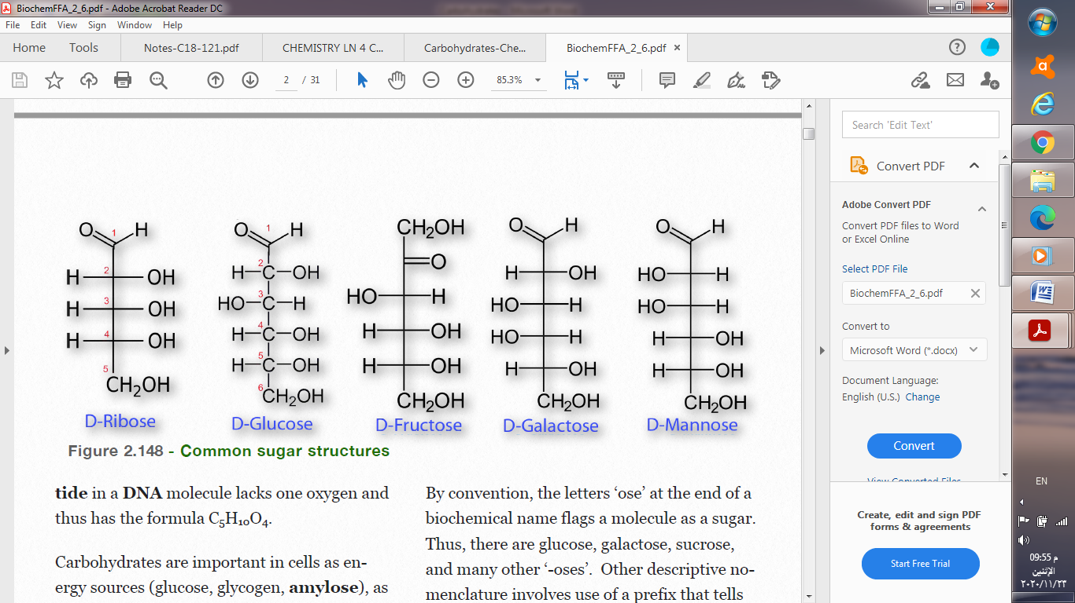

**Isomerism**

Isomerism is the phenomenon in which more than one compounds have the same chemical formula but different chemical structures. Chemical compounds that have identical chemical formulae but differ in properties and the arrangement of atoms in the molecule are called **isomers**. Monosaccharides are optically active compounds and can rotate the plane of polarized light either to right or to left.

• **D and L isomerism:**

When the OH group attached to the carbon atom which is next to the last CH2OH group is on the right, the sugar is described as D-sugar. If the OH group is on the left, it is described as L-sugar.



**. alpha and beta isomerism:**

These are isomers that differ in the position of the OH group at the anomeric C atom (C1 in glucose). If the OH group is on the right, the sugar is α-glucose, and if towards the left, it is β-glucose.



**2. Disaccharides:**

They are two monosaccharides connected by a bridging O atom called a glycosidic bond.



The most common ones include sucrose (glucose and fructose), lactose (galactose and glucose), and maltose (glucose and glucose).

**3. Oligosaccharides:**

Sometimes another group is used to classify carbohydrates. This is called oligo­saccharide (includes polymers from 3 to 10 sugar units in their molecules). This can be formed during the process of hydrolysis of polysaccharides.

**4. Polysaccharides:**

The molecule where ten or more sugar units are linked together is called a polysaccharide. Polysaccharides are non-reducing carbohydrates, and are not sweet.

**These are of two types:**

**(a) Homo- polysac­charides:**

All the sugar units are the same in the homo- polysaccharides, e.g. cellulose, which is a structural poly­saccharide, synthesised from β glucose units. Amylose is also called as polyglucose.

**(b) Hetero- polysac­charides:**

All the sugar units are different. e.g., sugar acids, amino sugars, etc. They are very common in nature (gums, pectin, and hyaluronic acid). Pectin is a type of starch, that occurs naturally in the cell walls of fruits and vegetables and gives them structure. Hyaluronic acid is a component of mammalian connective tissue, the vitreous humor of the eye. It is also associated with collagen.

**Some important polysaccharides:**

**I. Starch:**

The complete hydrolysis of starch occurs in three successive stages – dextrin, maltose, and then glucose. Heating in the presence of dilute acid can hydrolyze starch. In the human body several enzymes known collectively as amylase degrade it sequentially:

**[https://www.notesonzoology.com/wp-content/uploads/2016/10/clip_image036_thumb.jpg](https://www.notesonzoology.com/wp-content/uploads/2016/10/clip_image036.jpg)**

**II. Glycogen:**

Glycogen can be broken down into its D-glucose subunits by acid hydrolysis or by using amylase as in the case of starch. It is often called animal starch and is the reserve carbohydrate of animals. All animal cells store glycogen for emergency purposes, but it is abundant in the liver.

**III. Cellulose:**

Cellulose is a fibrous carbohydrate found in all plants and serves as a structural compo­nent of the plant’s cell wall.