Contents

Abstract 1
Introduction 2
Types of incretin hormones 3
GIP 5
GLP-1 6
Function of GIP 7
Secretion and Metabolism of GIP and GLP-1 8
Secretion of GIP 9
Secretion of GLP-1 10
Metabolism and Degredation of incretin 12
Physiological actions of incretins 12
GIP 13
GlP-1 14
Incretin receptors 18
DPP4 inhipitors 21
Sitagliptin and vildagliptin 21
Alogliptin and saxagliptin 22
Incretin-Based Therapies for T2DM 23
The development therapies for diabetes based on incretin action 24

Abstract:
Incretins are gut hormones that are secreted from enteroendocrine cells into the blood within minutes after eating. One of their many physiological roles is to regulate the amount of insulin that is secreted after eating. There are two incretins, known as glucose-dependent insulin tropic peptide (GIP) and glucagon-like peptide-1 (GLP-1), which share many common actions in the pancreas but have distinct actions outside of the pancreas ⁽¹⁾.
Both incretins are rapidly deactivated by an enzyme called dipeptidyl peptidase 4 (DPP4. Alack of secretion of incretins or an increase in their clearance are not pathogenic factors in diabetes. However, in type 2 diabetes (T2DM), GIP no longer modulates glucose-dependent insulin secretion, even at supraphysiological (pharmacological) plasma levels, and therefore GIP incompetence is detrimental to β-cell function, especially after eating.
Since 2005, two new classes of drugs based on incretin action have been approved for lowering blood glucose levels in T2DM: an incretin mimetic (exenatide, which is a potent long-acting agonist of the GLP-1 receptor) and an incretin enhancer (sitagliptin, which is a DPP4 inhibitor).
Exenatide is injected subcutaneously twice daily and its use leads to lower blood glucose and higher insulin levels, especially in the fed state. There is glucose-dependency to its insulin secretary capacity, making it unlikely to cause low blood sugars (hypoglycemia). DPP4 inhibitors are orally active and they increase endogenous blood levels of active incretins, thus leading to prolonged incretin action. The elevated levels of GLP-1 are thought to be the mechanism underlying their blood glucose-lowering effects.
Introduction:
Incretins are hormones that are released from the gut into the bloodstream in response to ingestion of food, and they then modulate the insulin secretary response to the products within the nutrients in the food. The insulin secretary response of incretins, called the incretin effect, accounts for at least 50% of the total insulin secreted after oral glucose. Therefore, by definition, incretin hormones are insulinotropic (i.e., they induce insulin secretion) at usual physiological concentrations seen in the plasma after ingestion.
In 1902, Bayliss and Starling ⁽¹⁾ published their landmark manuscript, “The Mechanism of Pancreatic Secretion.” The authors found that acid infused into the digestive system caused pancreatic secretion of juices through the pancreatic duct from the pancreas, even after they cut the enervation to the intestine. Until that time, it was thought that nervous system signals controlled secretion of pancreatic juices.
They carried out ground-breaking studies that led them to conclude that the nature of the signal to the pancreas was most likely a chemical stimulus: they removed extracts from the intestinal wall after it had been stimulated by acid, injected the extracts into the bloodstream, and once again they could see juices coming from the pancreatic duct of the animal that had been injected. Therefore, they proved that the extracts must have contained a substance that must normally be secreted from the intestinal wall into the bloodstream to stimulate the flow of pancreatic juice. They called the substance “secretin.” Starling introduced the word “hormone” (derived from the Greek word meaning “impetus”) for clinical factors that are released from one site and act on another ⁽¹⁾.
Moore wrote in 1906 that Bayliss and Starling considered the possibility that the duodenum also supplied a chemical excitant for the “internal” secretion of the pancreas. Moore (1906) ⁽²⁾ also described experiments carried out on individual young diabetic patients to whom he gave, by mouth, extracts of intestinal mucosa. This is therefore the first attempt at “incretin-based” therapies for treating diabetes, although, of course, the investigator did not call it that. He reported achieving some success, but his experiments were essentially doomed, because we now know that the chemical excitants are peptides that would have been degraded when given orally.
After World War I ended and insulin was extracted from pancreatic islets by Banting and Best in 1921, there was further work on the possibility of food entering the gut leading to secretion of an excitant into the bloodstream that would ultimately lead to insulin secretion and lowering of blood glucose. In 1932, La Barre used the word “incretin” to refer to an extract from upper gut mucosa that produces hypoglycemia but does not induce exocrine secretion, although he did not prove incontrovertibly that incretins existed.
Between 1964 and 1967, at least three groups showed independently that glucose, given orally, induced a greater insulin response (by radioimmunoassay) than i.v. glucose injection even if the blood glucose levels attained were higher because of the i.v. glucose ⁽³⁾.

Types of incretin hormones:
GIP and GLP-1 both belong to the glucagon peptide super family and thus share amino acid sequence homology. GIP and GLP-1 are secreted by specialized cells in the gastrointestinal tract ⁽⁴⁾ and have receptors located on islet cells as well as other tissues. As incretins, both are secreted from the intestine in response to ingestion of nutrients, which results in enhanced insulin secretion. The insulinotropic effect of GIP and GLP-1 is dependent on elevations in ambient glucose. Both are rapidly inactivated by the ubiquitous enzyme dipeptidyl peptidase IV (DPP-IV). The characteristics of GIP and GLP-1 are summarized in the table (1).
Characteristics | GIP | GLP-1
Peptide | 42 amino acid | 30/31 amino acid
Secreted by | K cells, primarily in duodenum and proximal jejunum | L cells, primarily in ileum and colon
Stimulated by | Oral ingestion of nutrients | Oral ingestion of nutrients
Metabolized by | DPP-IV | DPP-IV
Effects on insulin secretion | Stimulates | Stimulates
Effects on gastric emptying | Accelerates? | Slows
Effects on beta-cell proliferation | Stimulates* | Stimulates*
Effects on glucagon secretion | None significant | Suppresses
Effects on food intake | None significant | Reduces
Effects on insulin sensitivity | ? | Improves?
Secretion in type 2 diabetes | Preserved | Impaired
Insulinotropic response to exogenous administration in type 2 diabetes | Impaired | Preserved

Table 1: Characteristics of GIP and GLP-1
GIP:
It is known as Glucose-dependent Insulinotropic Peptide (Figure 1). GIP is a 42‐amino‐acid hormone secreted from K cells of the upper small intestine ^{(5, 6)}. It was originally isolated from porcine intestine on the basis of its ability to inhibit gastric acid secretion ⁽⁷⁾. Later, it was found that GIP administration stimulates insulin secretion in healthy volunteers ⁽⁸⁾, and that GIP acts directly on pancreatic islets to stimulate insulin secretion ^{(9,10)}. We have also shown that endogenous GIP stimulates insulin secretion glucose‐dependently in gastrectomized patients ^{(11).} These lines of evidence showed GIP to be the first incretin, which was then renamed glucose‐dependent insulinotropic polypeptide. Because immunological depletion of GIP did not abolish all insulin‐stimulating activity in gut extracts ⁽¹²⁾, the existence of a second incretin was inferred.
GLP-1:
It is known as Glucagon like peptide 1 GLP‐1, a 31‐amino‐acid hormone produced from proglucagon and secreted from L cells of the lower intestine and colon ⁽¹³⁾, directly acts on islets and stimulates insulin secretion in isolated islets ⁽¹⁴⁾ as well as in healthy volunteers ⁽¹⁵⁾ GLP‐1 was thus found to be the second incretin.
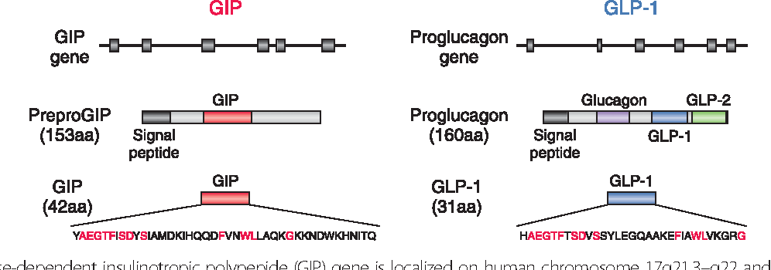
Figure 1:
GIP gene is localized on human chromosome 17q21.3-q21 and comprises 6 exons.proteolytic processing of prepare GIP generates GIP secreted from k cells. The proglucagon gene is localized in human chromosome 2q36-q37and comprises 6 exones.
Both GIP and GLP‐1 exert their effects by binding to their specific receptors, the GIP receptor (GIPR) ^{(16 ,17)} and the GLP‐1 receptor (GLP‐1R) ^{(18 ,19)}, which belong to the G‐protein coupled receptor family, activating adenylate cyclase and increasing levels of intracellular cyclic adenosine monophosphate (cAMP) in pancreatic β cells, thereby stimulating insulin section glucose‐dependently.
Genetic ablation of GIPR and GLP‐1R separately or simultaneously in mice showed their critical roles in the enter‐insular axis and confirmed that both GIP and GLP‐1 act as incretins ^{(20, 21)}. Furthermore, deficiency of dipeptidyl peptidase‐4 (DDP‐4), which cleaves the two NH₂‐terminal amino acids of GIP and GLP‐1 in plasma and inactivates their insulinotropic activities ^{(22, 23)}, enhances insulin secretion in response to oral glucose challenge consistently with their function as incretins ⁽²⁴⁾. GIP and GLP‐1 thus share common properties as incretins, but they also possess different biological characteristics (Figure 2). Here, we summarize similarities and differences in the processes of the secretion and metabolism of GIP and GLP‐1, their insulinotropic actions on pancreatic β cells, and their non‐insulinotropic effects.
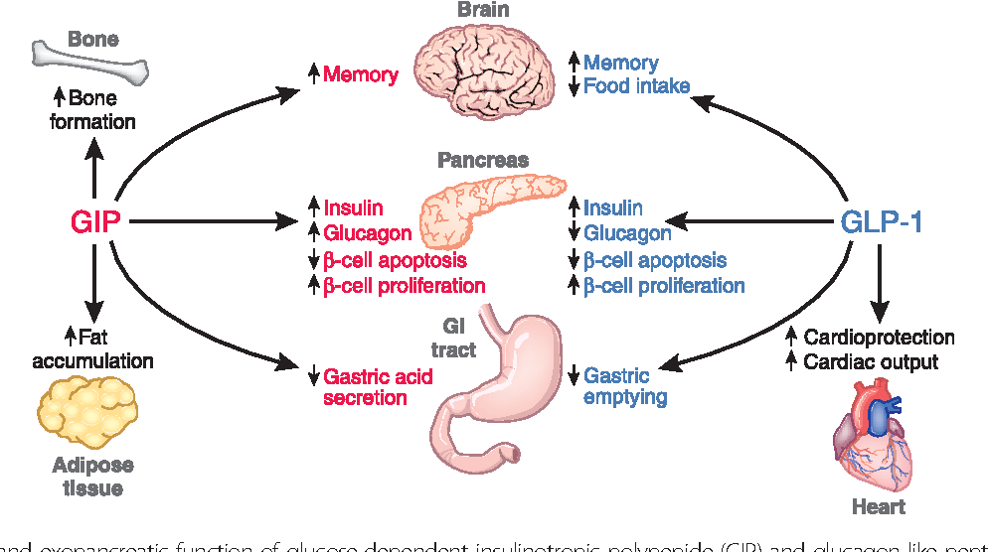
Figure 2:
Pancreatic and exopancreatic function of GIP and GLP-1. GIP acts directly on pancreas, bone, brain, fat and gastrointestinal tract. GlP-1 acts directly on endocrine pancreas, heart, brain and GI.

Function of GIP:
1- Gastric inhibitory peptide and was found to decrease the secretion of stomach acid ⁽²⁵⁾ to protect the small intestine from acid damage.
2- Reduce the rate at which food is transferred through the stomach .
3- Inhibit the GI motility and secretion of acid.
However, this is incorrect, as it was discovered that these effects are achieved only with higher-than-normal physiological level, and that these results naturally occur in the body through a similar hormone, secretin.
It is now believed that the function of GIP is to induce insulin secretion, which is stimulated primarily by hyperosmolarity of glucose in the duodenum ⁽²⁶⁾. After this discovery, some researchers prefer the new name of glucose-dependent insulinotropic peptide, while retaining the acronym "GIP." The amount of insulin secreted is greater when glucose is administered orally than intravenously ⁽²⁷⁾.
GIP recently appeared as a major player in bone remodeling. Researchers at Universities of Angers and Ulster evidenced that genetic ablation of the GIP receptor in mice resulted in profound alterations of bone micro architecture through modification of the adipokine network. Furthermore, the deficiency in GIP receptors has also been associated in mice with a dramatic decrease in bone quality and a subsequent increase in fracture risk ⁽²⁸⁾.

Secretion and Metabolism of GIP and GLP-1:
Because GIP and GLP‐1 rapidly undergo proteolytic degradation catalyzed by DPP‐4⁽²⁹⁾, not only intact but also total forms of GIP and GLP‐1 must be measured to study their secretion and processing vivo in (Figure 3). However, immunoassays for GIP and GLP‐1 levels, especially those used to measure their intact forms in plasma require specific antibodies and are not widely available ⁽³⁰⁾. Furthermore, because carboxyl‐terminal arginine of GLP‐1 is susceptible to amidation, GLP‐1 occurs in both non‐amidated GLP‐1 and amidated GLP‐1 amide, both of which show similar insulinotropic effects and metabolism in humans. Although most of the GLP‐1 secreted from the gut is amidated in humans, careful considerations are required when measuring the levels of GLP‐1 because some antibodies only recognize amidated GLP‐1.
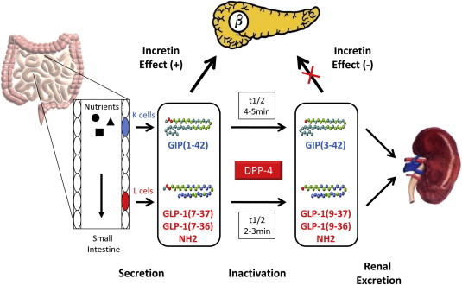
Figure 3:
Secretion and metabolism of (GIP) and (GLP) ‐1. GIP is secreted from K cells of the upper intestine; GLP‐1 is secreted from L cells of the lower intestine
Secretion of Glucose-dependent insulinotropic polypeptide:
GIP secretion from K cells is enhanced in response to ingestion of meals or glucose ⁽³¹⁾. pM in healthy Caucasians A series of studies using the antibody R65, which recognizes both intact GIP and DPP‐4‐processed GIP, shows that plasma levels of total GIP at fasting are 5–20 min in response to ingestion of mixed meals pM within 60 min in response to ingestion of 75‐gram glucose in healthy Caucasians, whereas those of total GIP reach 100–150 pM within 30, indicating basal secretion in healthy Caucasians.
These levels of total GIP reach 50–100. Although there is no direct comparison of glucose‐enhanced GIP secretion with those enhanced by proteins or fats, ingestion of proteins produces more rapid and robust GIP secretion than that of fats .
Secretion of Glucagon-like peptide 1:
GLP‐1 secretion from L cells, like that of GIP from K cells, is enhanced in response to ingestion of meals or glucose ⁽³¹⁾. pM, indicating basal secretion in healthy Caucasians Studies using antiserum 89390 specific for GLP‐1 amide as well as DPP‐4‐processed GLP‐1 amide show that plasma levels of total GLP‐1 at fasting are 10–20 min in response to ingestion of 75‐gram glucose or mixed meals in healthy Caucasians pM within 30 (Figure 4).

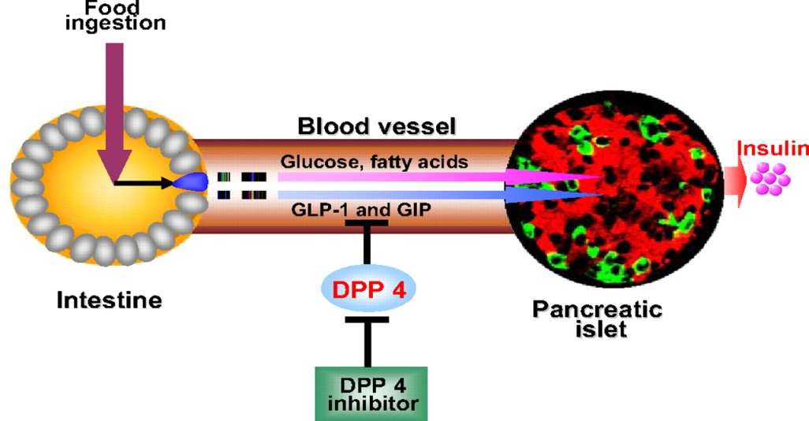
Figure 4:
GIP and GLP-1 are secreted after food ingestion, and they then stimulate Glucose-dependent insulin secretion, once they are released they are degraded by DPP4 on lymphatocytes and endothelial cell of blood vessel.
Levels of total GLP‐1 reach 30–60. Despite the lack of direct comparison of glucose‐enhanced GLP‐1 secretion with those enhanced by proteins or fats, ingestion of proteins or isocaloric fats produces a similar GLP‐1 secretion (Figure 5) ⁽³²⁾.
Evaluation of GLP‐1 secretion in healthy Japanese subjects using the same immunoassay detecting total GLP‐1 with antiserum 89390 showed that the meal‐induced enhancement of GLP‐1 secretion is negligible, whereas GLP‐1 secretion in response to oral glucose is similar to that in healthy Caucasians ^{(33, 34)}.
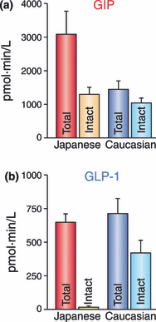
Figure 5:
Racial differences in secretion and metabolism of (a) (GIP) and (b) (GLP) ‐1. GIP secretion in healthy Japanese subjects after ingestion of glucose or mixed meals were higher than those of healthy Caucasian subjects, whereas levels of intact GIP were similar.
Metabolism and Degradation of incretin:
Both incretin hormones are rapidly degraded and removed from the circulation by the enzyme dipeptidyl peptidase 4 (DPP-4); consequently, intact GLP-1 and GIP are important for regulation of insulin release via the endocrine pathway, whereas total levels of the incretins reflect their secretion more ⁽³⁴⁾. DPP-4 is a serine protease that is widely distributed in the body, including the vascular endothelium, and is also present as a circulating form.
High circulating levels of the enzyme could indicate that the incretins might be degraded more rapidly in obese than in lean subjects, and it could, therefore, be speculated that increased rates of metabolism of the incretin hormones in obesity may contribute to changes in postprandial incretin and islet hormone secretion.
However, although incretin hormone secretion and metabolism have been examined in subjects with type 2 diabetes or insulin resistance, simultaneous measurements of DPP-4 activity and plasma concentrations of the intact incretin hormones and their metabolites after ingestion of a mixed meal or oral glucose have not been performed in obese vs. lean no diabetic subjects. To obtain such information, we investigated the relationship between total and intact incretins and the islet hormones throughout a 5-h period after ingestion of a mixed meal or glucose in lean and obese healthy subjects.
Physiological actions of incretins:
Glucose-dependent insulinotropic peptide:
1-Action on insulin secretion:
GIP exerts glucose-dependent stimulatory effects on insulin secretion in animals and humans ⁽³⁵⁾. The incretin function of GIP was first studied in dogs and rodents, using GIP antagonists and GIP receptorantisera (“neutralization studies”).
When given alone, these compounds induced a reduction in the insulin response to oral glucose; when given concomitantly with exogenous GIP, they attenuated its insulinotropic effects ⁽³⁶⁾.
As the glucose intolerance found in this experimental model was not very severe, it was concluded that GIP is not the only incretin hormone and that other insulinotropic agents are secreted, which compensate the lack of GIP receptor activation ⁽³⁷⁾. Results of studies in humans as well as studies in mice with double knockout of the GIP and GLP-1 receptors consistently showed an additive effect of the two hormones GIP and GLP-1 in the incretin effect ⁽³⁶⁾.
In physiological conditions, it appears that smaller loads of rapidly absorbable nutrients would preferentially activate the upper incretin hormone GIP, whereas ingestion of larger meal containing more complex nutrients would also activate the distal incretin GLP-1.
2-effect on fat metabolism:
There is experimental evidence indicating that GIP regulates fat metabolism in adiposities, including enhanced insulin-stimulated incorporation of fatty acids into triglycerides, stimulation of lipoprotein lipase activity, stimulation of fatty acids synthesis. At present, the exact signaling mechanisms mediating the effects of GIP on fat cells are unknown ⁽³⁷⁾.
3-other actions:
GIP has been shown to promote beta cell proliferation and cell survival in islet cell line studies ⁽³⁸⁾. In contrast with GLP-1, GIP does not influence pancreatic alpha cell secretion of glucagon in humans, nor does it affect gastric emptying (Figure 6).
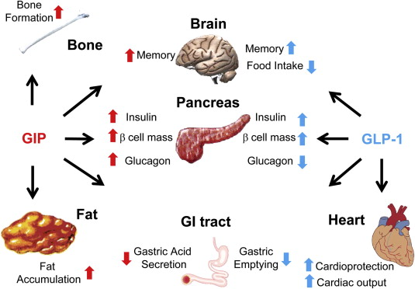
Figure 6:
Biological function of incretin GIP and GlP-1. Where they acts directly on Bone, fat, brain, endocrine pancreas, fat and GI tract.
Glucagon like peptide 1:
1-effects on insulin secretion:
GLP-1 stimulates glucose-induced insulin secretion in isolated islets of Langerhans, in the perfused pancreas and in whole organisms, in animals and humans.
In humans, secretion of GLP-1 throughout the day is strongly correlated to the release of insulin ⁽³⁹⁾. The effect of GLP-1 on insulin secretion is strictly glucose-dependent and there is no effect of GLP-1 on insulin secretion for glucose concentrations below a certain threshold (approximately 4.5 mmol/l).
The incretin activity of GLP-1 has been recognized from studies performed in healthy subjects, using exogenous GLP-1.
However, the contribution of the incretin effect in normal subjects is a matter of debate (Figure 6). A number of experimental data suggest that GLP-1 is responsible for a substantial part of the insulin response to oral glucose, whereas other experiments suggest that the contribution might be rather small in normal conditions ⁽⁴⁰⁾.
2- Effects on somatostation secretion:
GLP-1 is a potent stimulator of somatostatin secretion from isolated human islets. This effect is not dependent on glucose concentrations ⁽⁴¹⁾.
3 effects on glucagon-Inhibitory secretion:
GLP-1 is able to suppress glucagon secretion in pancreatic islets, in perfused pancreas and in whole organisms. The mechanism by which GLP-1 inhibits glucagon secretion remains to be elucidated. The inhibitory effect is probably indirectly mediated via insulin release and via somatostatin secretion. However, a direct effect of GLP-1 is not completely excluded since GLP-1 receptors are expressed on pancreatic glucagon cells ⁽⁴²⁾.
The inhibitory effects of GLP-1 on glucagon secretion seem to represent an important mechanism for regulating elevated levels of blood glucose. In patients with type 1 diabetes (i.e. who had no insulin effect), administration of GLP-1 decreased blood glucose levels while the secretion of glucagon was strongly inhibited, suggesting that GLP-1 suppressed the hepatic production of glucose induced by glucagon ⁽⁴³⁾.
The inhibition of glucagon secretion by GLP-1 is glucose dependent, meaning that GLP-1 administration is unlikely to impair the glucagon counter regulatory response to hypoglycemia ⁽⁴⁴⁾.
4- Effects on the gastrointestinal tract:
GLP-1 exerts inhibitory effects on gastrointestinal secretion and motility, particularly on gastric emptying ⁽⁴⁵⁾. Administration of GLP-1 at physiological doses in healthy volunteers results in a dose-dependent slowing of gastric emptying and of glucose absorption, which participate in a subsequent reduction of postprandial plasma glucose concentration ⁽⁴⁶⁾. These effects suggest the participation of GLP-1 in the “ilea brake” phenomenon, by which nutrients present in the distal part of the small intestine induce a reduction in upper intestinal motility and secretary activity.
The physiological role of GLP-1 may be to adjust the absorptive capacity of the gut and to adjust the amount of chyme, by slowing gastrointestinal transit and decreasing secretion of digestive enzymes.
In physiological conditions, it is likely that the gastrointestinal effects of GLP-1, (i.e. reduction of gastric secretion and slowing of gastric emptying) are more important than its insulinotropic action ⁽⁴⁶⁾. In pathological conditions such as diabetes, the inhibitory effects of GLP-1 on gastrointestinal motility, particularly gastric emptying, are of special interest because they potentially reduce postprandial glucose excursions.

5-Effects on food intake:
GLP-1 has been shown to reduce caloric intake and to enhance satiety, these effects ⁽⁴⁷⁾ being probably related to central mechanisms. Significant reduction of food intake and consequently lower weight gain. In normal subjects, the intravenous administration of GLP-1 above physiological levels induced increased feelings of satiety as well as a reduction of food intake ⁽⁴⁸⁾.
Similar effects were observed in obese subjects, as well as in patients with type 2 diabetes. In type 2 diabetic patients treated with a subcutaneous infusion of GLP-1 for up to 6 weeks, the reduction of food intake was sustained and associated with a reduction of body weight ⁽⁴⁹⁾.
6- Trophic effect on pancreas:
GLP-1 has been shown to exert atrophic effects on pancreatic beta cell mass. When given for prolonged periods to normal rodents or to animals with impaired glucose tolerance or diabetes, GLP-1 and its long acting a loge Exendin 4 increased beta cell mass.
GLP-1 also promoted the differentiation of beta precursor cells in the pancreatic duct epithelium. In addition, GLP-1 exhibited antiapoptotic effects in beta cells of rodent models (Zucker diabetic fatty rats). Unlike insulinotropic effects dependent on Protein Kinas a (PKA) pathways, the atrophic and survival effects of GLP-1 are probably mediated through different signaling pathways (Figure 7).
Whether GLP-1 also expresses pancreatic atrophic properties in vivo in human remains to be confirmed. Nevertheless, these findings raise considerable interest from a clinical perspective, as GLP-1 and GLP-1 analogues could be potentially useful in preserving functional beta cell mass in patients with type 2 diabetes.
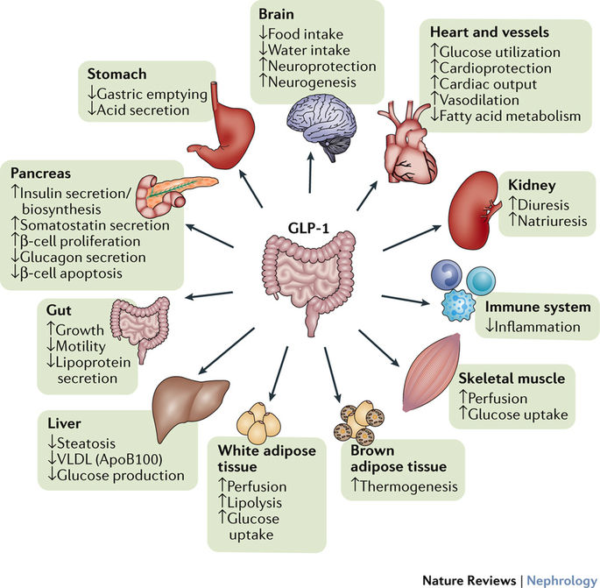
Figure 7:
Physiological effect of GLP-1 in different organs.
Incretin receptors:
Both the receptors for GIP and GLP-1 are members of the secretin family or class B G protein-coupled receptors (GPCRs). Although GLP-1R and GIP-R share considerable sequence homology (approximately 40%), they display extremely high selectivity for their respective ligands.
Family B GPCRs have a large extracellular N-terminal domain (NTD) linked to the 7-transmembrane helical domain that is characteristic of all GPCRs. The C-terminal region of the peptide ligand binds the NTD of the receptor, facilitating a secondary interaction between the N-terminal region of the peptide and the ‘core’ or transmembrane domain (TMD) of the receptor (Figure 8). This secondary interaction is thought to lead to activation of the receptor, allowing the TMD to interact with and activate heterotrimeric G proteins.
However, recent data for both GIP-R and GLP-1R have shown that peptides that comprise the central region of GIP and GLP-1 are also able to activate their respective receptors. Therefore, this situation requires a rethinking of the current model of ligand binding and activation for this class of receptors (Figure 9).
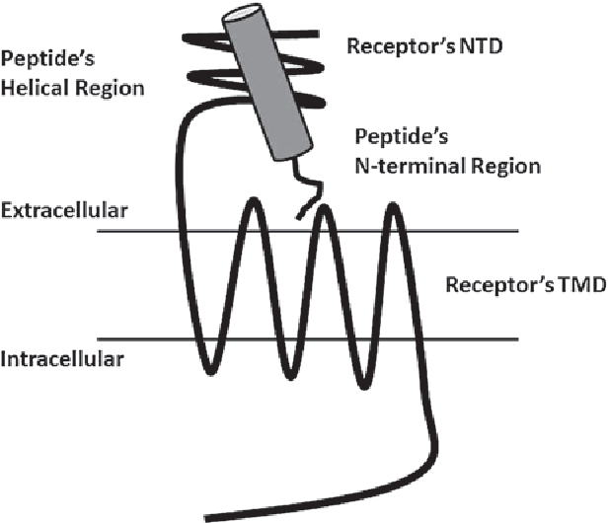
Figure 8:
This model for peptide ligand binding to incretin receptor. The helical region of the peptide ligand binds to the NTD of the receptor, allowing the N terminal region of the peptide to interact with the receptor TMP.

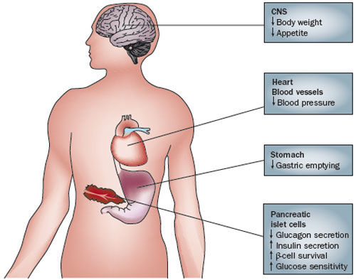

Figure 9:

GLP-1 receptor agonists exert diverse actions on distinct target tissues, which lead to reduction of blood glucose level and body weight in humans.
Structures of both the NTD of GIP-R and GLP-1R in complex with their respective ligands had been solved and have confirmed that the C-terminal region of the peptide binds to this domain. The structure of the TMD of either GIP-R or GLP-1R is yet to be determined.
To date, the only members of the class B family of GPCRs which have crystal structures of their TMD published are the corticotrophin-releasing factor receptor 1 and the glucagon receptor. These structures provide valuable insight into the structure and function of this family of receptors and can be used as a template to model the structure of GIP-R and GLP-1R. However, as they do not include the NTD, the orientation of this region in relation to the TMD and how peptide ligands alter this structure remain to be solved.

DPP4 inhibitors:

Sitagliptin and vildagliptin

DPP-4 inhibitors, sometimes called 'incretin enhancers', exert their glucose-regulatory actions through prolongation of the actions of GLP-1 and, to a lesser extent, GIP. Sitagliptin was approved for use in the US in October 2006 and in other countries thereafter, and vildagliptin was subsequently approved for use in Europe and other countries but not in the US. DPP-4 inhibitors may be administered orally, once daily (sitagliptin) or twice daily (vildagliptin), they do not influence body weight, and are well tolerated. All DPP-4 inhibitors (sitagliptin, vildagliptin and other agents in late stages of clinical testing) are selective for DPP-4, but exert differential affinity for DPP-4-related enzymes when tested with recombinant enzymes in vitro.

Alogliptin and saxagliptin

Alogliptin is DPP-4 inhibitor that has been investigated in phase III clinical trials as monotherapy or in combination with other oral antidiabetic agents (metformin, sulfonylurea, or thiazolidinedione). Alogliptin has been evaluated as monotherapy for 26 weeks in patients with poorly controlled diabetes mellitus at doses of 12.5 mg or 25 mg daily, which achieved reductions in HbA_{1c} levels of 0.56% and 0.59%, respectively, and seemed to be well tolerated. Alogliptin, used at doses of 12.5 mg and 25 mg once daily, also lowered patients' blood glucose levels when it was added to existing therapy in patients who had responded inadequately to metformin alone (Figure 10).
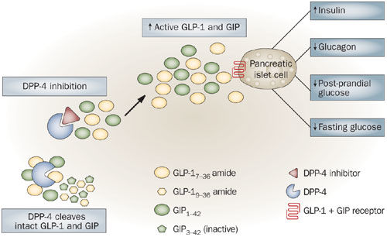
Figure 10:
Mechanism of action of DPP4 inhibitors.
Incretin-Based Therapies for T2DM:
Although endogenous GIP exerts strong insulinotropic effects in healthy subjects, the severe reduction in the insulinotropic effect of GIP and the GIP‐dependent enhancement of postprandial glucagon response have discouraged development of GIP‐based therapies for T2DM.
In contrast, the insulinotropic effect of GLP‐1 is substantially preserved in T2DM. Long‐term intravenous infusion of GLP‐1 has been shown to improve glycemic control, establishing GLP‐1 and GLP‐1R signaling as attractive therapeutic targets for T2DM. Indeed, GLP‐1R agonists (e.g. liraglutide and exenatide) and DPP‐4 inhibitors (e.g. sitagliptin and vildagliptin) have been widely and successfully used.
Furthermore, recent clinical data suggest that incretin‐based therapies are more effective in Japanese patients compared with Caucasian patients. The effectiveness of incretin‐based therapies is consistent with the reduced early insulin secretary capacity in T2DM patients in Asia countries including Japan, and further suggests that such reduced early insulin secretary capacity could be partly due to their considerably lower levels of intact GLP‐1, which has been recently revealed in Japanese subjects.
Incretin‐based therapies have recently become widely available in Asian countries. However, their effectiveness in the regulation of long‐term glycemic control, preservation of β cell mass and function, and the prevention of macro and micro complications are not known and must be carefully followed for years.
Nevertheless, given the pathophysiology of Asian T2DM (insulin deficiency rather than insulin resistance), incretin‐based therapies that primarily correct impaired early insulin secretion might well be highly suitable in the treatment of Asian T2DM and have the potential to be a first choice therapy as is presently the case for metformin in Caucasian T2DM.
The development therapies for diabetes based on incretin action:
[1] Exinatide:
Exenatide is the most advanced candidate drug in the clinical development of GLP-1 analogues. Exenatide is the synthetic version of exendin-4, a peptide originally isolated from the saliva of the lizard Heloderma suspectum (Gila monster), showing a 53% amino acid homology with mammalian GLP-1.
Exendin-4 acts as a full agonist at the GLP1 receptor. This new compound:
1-exhibited glucoregulatory actions in a large number of preclinical experiments (glucose-dependent enhancement of insulin secretion, glucose-dependent inhibition of glucagon secretion) .
2-slowing gastric emptying and reducing food intake.
3- exendin-4 has been shown to promote beta-cell proliferation and islet neogenesis from precursor cells in vitro and in vivo ^{[43]}.
In human studies, exenatide is commonly administered as a twice-daily subcutaneous injection (SC), the plasma half life being estimated at 2-4 hours. In preliminary clinical studies performed in healthy volunteers and in type 2 diabetic patients, exenatide reduced both fasting and post prandial glucose excursions.
[2] Liraglutide:
Liraglutide is a long-acting acylated GLP-1 analogue, acting as a full agonist toward the GLP-1 receptor ^{[51]}. The compound is administered as a once-daily subcutaneous injection (SC) in humans (half-life of approximately 12 hours). Animal and human studies have demonstrated blood glucose-lowering effects.
In a recent comparative phase II trial (12-week duration) in type 2 diabetic patients, liraglutide provided effective glycemic control (i.e. HbA_{1c}, and was not associated with weight gain ^{[52]}.
The results of a 5-week study performed in 144 type 2 diabetic patients demonstrated that liraglutide, used alone or combined with metformin, significantly reduced levels of fasting plasma glucose in diabetic patients compared to metformin treatment alone or to combined metformine and glimepiride therapy.

Reference
1- Starling EH. The Cronian Lectures on the chemical correlation of the functions of the body. Lancet. 1905; 2:339–341. 423–425, 501–503, 579–583
2-Mortensen K, Christensen LL, Holst JJ, Orskov C. GLP-1 and GIP are colocalized in a subset of endocrine cells in the small intestine. Regular Pept. 2003; 114:189–196.
3- Perley MJ, Kipnis DM J Clin Invest. Plasma insulin responses to oral and intravenous glucose studies in normal and diabetic sujbjects. 1967; 46(12):1954-62
4- Taminato T, Seino Y, Goto Y, et al. Synthetic gastric inhibitory polypeptide. Stimulatory effect on insulin and glucagon secretion in the rat. Diabetes 1977; 26: 480–484
5-Inagaki N, Seino Y, Takeda J, et al. Gastric inhibitory polypeptide: Structure and chromosomal localization of the human gene. Mol Endocrinal 1989; 3: 1014–1021
6- Takeda J, Seino Y, Tanaka K, et al. Sequence of an intestinal cDNA encoding human gastric inhibitory polypeptide precursor. Proc Natl Acad Sci 1987; 84: 7005–7008
7- Brown JC, Mutt V, Pederson RA. Further purification of a polypeptide demonstrating enterogastrone activity. J Physiol 1970; 209: 57–64
8- Dupre J, Ross SA, Watson D, et al. Stimulation of insulin secretion by gastric inhibitory polypeptide in man. J Clin Endocrinol Metab 1973; 37: 826–828
9-Adrian TE, Bloom SR, Hermansen K, et al. Pancreatic polypeptide, glucagon and insulin secretion from the isolated perfused canine pancreas. Diabetologia 1978; 14: 413–417
10- Taminato T, Seino Y, Goto Y, et al. Synthetic gastric inhibitory polypeptide. Stimulatory effect on insulin and glucagon secretion in the rat. Diabetes 1977; 26: 480–484
11-Takemura J, Seino Y, Yamamura T, et al. The role of endogenous gastric inhibitory polypeptide in the enteroinsular axis. J Clin Endocrinol Metab 1982; 54: 909–913
12- Ebert R, Unger H, Creutzfeldt W. Preservation of incretin activity after removal of gastric inhibitory polypeptide (GIP) from rat gut extracts by immunoadsorption. Diabetologia 1983; 24: 449–454
13- Bell GI, Santerre RF, Mullenbach GT. Hamster preproglucagon contains the sequence of glucagon and two related peptides. Nature 1983; 302: 716–718
14-Schmidt WE, Siegel EG, Creutzfeldt W. Glucagon‐like peptide‐1 but not glucagon‐like peptide‐2 stimulates insulin release from isolated rat pancreatic islets. Diabetologia 1985; 28: 704–707
15-Kreymann B, Williams G, Ghatei MA, et al. Glucagon‐like peptide‐1 7‐36: A physiological incretin in man. Lancet 1987; 2: 1300–1304
16- Gremlich S, Porret A, Hani EH, et al. Cloning, functional expression, and chromosomal localization of the human pancreatic islet glucose‐dependent insulinotropic polypeptide receptor. Diabetes 1995; 44: 1202–1208
17-Yasuda K, Inagaki N, Yamada Y, et al. Hamster gastric inhibitory polypeptide receptor expressed in pancreatic islets and clonal insulin‐secreting cells: Its structure and functional properties. Biochem Biophys Res Commun 1994; 205: 1556–1562
18-Dillon JS, Tanizawa Y, Wheeler MB, et al. Cloning and functional expression of the human glucagon‐like peptide‐1 (GLP‐1) receptor. Endocrinology 1993; 133: 1907–1910
19-Thorens B. Expression cloning of the pancreatic beta cell receptor for the gluco‐incretin hormone glucagon‐like peptide 1. Proc Natl Acad Sci 1992; 89: 8641–8645
20-Hansotia T, Baggio LL, Delmeire D, et al. Double incretin receptor knockout (DIRKO) mice reveal an essential role for the enteroinsular axis in transducing the glucoregulatory actions of DPP‐IV inhibitors. Diabetes 2004; 53: 1326–1335
21-Miyawaki K, Yamada Y, Yano H, et al. Glucose intolerance caused by a defect in the entero‐insular axis: a study in gastric inhibitory polypeptide receptor knockout mice. Proc Natl Acad Sci 1996: 14843–14847
22-Kieffer TJ, McIntosh CH, Pederson RA. Degradation of glucose‐dependent insulinotropic polypeptide and truncated glucagon‐like peptide 1 in vitro and in vivo by dipeptidyl peptidase IV. Endocrinology 1995; 136: 3585–3596
23-Mentlein R, Gallwitz B, Schmidt WE. Dipeptidyl‐peptidase IV hydrolyses gastric inhibitory polypeptide, glucagon‐like peptide‐1amide, peptide histidine methionine and is responsible for their degradation in human serum. Eur J Biochem 1993; 214: 829–835
24-Marguet D, Baggio L, Kobayashi T, et al. Enhanced insulin secretion and improved glucose tolerance in mice lacking CD26. Proc Natl Acad Sci 2000; 97: 6874–6879
25- Kim W, Egan JM. "The role of incretins in glucose homeostasis and diabetes treatment".Pharmacological Reviews. 2008; 60 (4): 470–512.
26-Thorens B. "Glucagon-like peptide-1 and control of insulin secretion". Diabetes & Metabolism. 1995; 21 (5): 311–8.
27- Gaudin-Audrain C, Irwin N, Mansur S, Flatt PR, Thorens B, Baslé M, Chappard D, Mabilleau G. "Glucose-dependent insulinotropic polypeptide receptor deficiency leads to modifications of trabecular bone volume and quality in mice". Bone 2013; 53 (1): 221–30.
28-Mieczkowska A, Irwin N, Flatt PR, Chappard D, Mabilleau G. "Glucose-dependent insulinotropic polypeptide (GIP) receptor deletion leads to reduced bone strength and quality". Bone 2013; 56 (2): 337–42.
29-Mentlein R, Gallwitz B, Schmidt WE. Dipeptidyl‐peptidase IV hydrolyses gastric inhibitory polypeptide, glucagon‐like peptide‐1 (7‐36) amide, peptide histidine methionine and is responsible for their degradation in human serum. Eur J Biochem1993; 214: 829–835.
30- Deacon CF, Holst JJ. Immunoassays for the incretin hormones GIP and GLP‐1.Best Pract Res Clin Endocrinol Metab 2009; 23: 425–432.
31-Vollmer K, Holst JJ, Baller B, et al. Predictors of incretin concentrations in subjects with normal, impaired, and diabetic glucose tolerance. Diabetes 2008; 57: 678–687.
32-Carr RD, Larsen MO, Winzell MS, et al. Incretin and islet hormonal responses to fat and protein ingestion in healthy men. Am J Physiol Endocrinal Metab 2008; 295: E779–E784.
33-Meier JJ, Nauck MA, Kranz D, et al. Secretion, degradation, and elimination of glucagon‐like peptide 1 and gastric inhibitory polypeptide in patients with chronic renal insufficiency and healthy control subjects. Diabetes 2004; 53: 654–662.
34-Yabe D, Kuroe A, Lee S, et al. little enhancement of meal‐induced GLP‐1 secretion in Japanese: Comparison of type 2 diabetes and healthy controls. J Diabetes Invest 2010; 1: 56–59.
35-Dupre J, Ross SA, Watson D, Brown JC. Stimulation of insulin by gastric inhibitory polypeptide in man. J Clin Endocrinal Metab, 1973; 37; 826-8.

36- Myiawaki K, Yamada Y, Yano H, et al. Glucose intolerance caused by a defect in the enteroinsular axis: a study in gastric inhibitory polypeptide receptor knockout mice. Proc Natl Acad Sci, 1999; 96; 14843-7.

37- Yip RGC and Wolfe MM. GIP biology and fat metabolism. Life Sciences, 2000; 66: 91-103.

38-Trumper A, Trumper K, Trusheim H, Arnold R, Goke B, Horsch D.
Glucose-dependent insulinotropic polypeptide is a growth factor for
Beta (INS-1) cells by pleiotropic signalling. Mol Endocrinol, 2001; 15;
1559-70.
39- Orskov C, Wettergren A, Holst JJ. Secretion of the incretin hormones glucagon-like peptide-1 and gastric inhibitory polypeptide correlates with insulin secretion in normal man throughout the day. Scand J Gastroenterol, 1996, 31, 665-70.

40- Nauck MA, Niedereichholtz U, Ettler R, Holst JJ, Orskov C, Schmeigel WH. Inhibition of gastric emptying by physiological and pharmacological doses of exogenous glucagon-like peptide -1 (GLP-1) outweighs insulinotropic effects in healthy normoglycemic volunteers. Am J Physiol, 1997; 273; E981-E988.

41- Fehmann HC, Goke R, Goke B. Cell and molecular biology of the incretin hormones glucagon-like peptide 1 and glucose dependent insulin releasing polypeptide. Endocrine Rev, 1995, 16, 390-410.

42- Holst JJ. Therapy of type 2 diabetes mellitus based on the actions of glucagon-like peptide-1. Diabetes Metab Res Rev, 2002; 18; 430-41.

43-Creutzfeldt WO, Kleine N, Willms B, Orskov C, Holst JJ, Nauck MA. Glucagonostatic actions and reduction of fasting hyperglycaemia by exogenous glucagon-like peptide-1 amide in type I diabetic patients. Diabetes Care, 1996; 19; 580-6.

44-Nauck MA, Heimesaat MM, Behle K, et al. Effects of glucagon-like peptide 1 on counter regulatory hormone responses, cognitive functions and insulin secretion during hyperinsulinemic stepped hypoglycemic clamp experiments in healthy volunteers. J Clin Endocrinol Metab, 2002; 87; 1239-46.

45- Holst JJ. Therapy of type 2 diabetes mellitus based on the actions of glucagon-like peptide-1. Diabetes Metab Res Rev, 2002; 18; 430-41.

46-Nauck MA, Niedereichholtz U, Ettler R, Holst JJ, Orskov C, Schmeigel WH. Inhibition of gastric emptying by physiological and pharmacological doses of exogenous glucagon-like peptide -1 (GLP-1) outweighs insulinotropic effects in healthy normoglycemic volunteers. Am J Physiol, 1997; 273; E981-E988.

47- van Dijk G, Thiele TE. Glucagon-like peptide-1(7-36) amide: a central regulator of satiety and interoceptive stress. Neuropeptides, 1999; 33; 406-14.

48- Flint A, Raben A, Astrup A, Holst JJ. Glucagon-like peptide 1 promotes satiety and suppresses energy intakes in humans. J Clin Invest, 1998; 101; 515-20.

49- Zander M, Madsbad S, Madsen JL, Holst JJ. Effect of 6-week course of glucagon-like peptide 1 on glycemic control, insulin sensitivity, and β-cell function in type 2 diabetes: a parallel-group study. Lancet, 2002; 359; 824-30.

50-Farilla L, Bulotta A, Hirshberg B, et al. Glucagon-like peptide-1 inhibits cell apoptosis and improves glucose responsiveness of freshly isolated human islets. Endocrinology, 2003; 141; 5149-58.

51- Mayo KE, Miller LJ, Bataille D, Dalle S, Göke B, Thorens B, Drucker DJ Pharmacol Rev.2003;55(1):167-94.
52- Al-Sabah S, Al-Fulaij M, Ahmed HA Eur J Pharmacol.Selectivity of peptide ligands for the human incretin receptors expressed in HEK-293 cells. 2014; 741:311-5.
53- Al-Sabah S, Donnelly D Br J Pharmacol. A model for receptor-peptide binding at the glucagon-like peptide-1 (GLP-1) receptor through analysis of truncated ligands and receptors. 2003; 140(2):339-46.
54- Donnelly D Br J Pharmacol. The structure and function of the glucagon-like peptide-1 receptor and its ligands. 2012; 166(1):27-41.
55- Hollenstein K, Kean J, Bortolato A, Cheng RK, Doré AS, Jazayeri A, Cooke RM, Weir M, Marshall FH Nature. Structure of class B GPCR corticotropin-releasing factor receptor 1. 2013; 499(7459):438-43.
56- Weber AE. Dipeptidyl peptidase IV inhibitors for the treatment of diabetes. J Med Chem 2004; 47: 4135–41.
57- Augeri DJ, Robl JA, Betebenner DA, et al. Discovery and preclinical profile of saxagliptin (BMS-477118): a highly potent, long-acting, orally active dipeptidyl peptidase IV inhibitor for the treatment of type 2 diabetes. J Med Chem 2005; 48: 5025–37.

59- Ahrén B, Gomis R, Standl E, Mills D, Schweizer A. Twelve- and 52-week efficacy of the dipeptidyl peptidase IV inhibitor LAF237 in metformin-treated patients with type 2 diabetes. Diabetes Care 2004; 27: 2874–80.
60- Ahrens B, Giovanni P, Foley JE, Schweitzer A. Improved meal-related β-cell function and insulin sensitivity by the dipeptidyl peptidase-IV inhibitor vildagliptin in metformin-treated patients with type 2 diabetes over 1 year. Diabetes Care 2005; 28: 1936–40.
61- Anefeld M, Herman G, Mickel C, et al. Effect of MK-0431, a dipeptidyl peptidase IV (DPP-IV) inhibitor, on glycemic control after 12 weeks in patients with type 2 diabetes. Diabetologia 2005; 48(Suppl 1): A287.
62- Nauck MA, Bartels E, Orskov C, et al. Additive insulinotropic effects of exogenous synthetic human gastric inhibitory polypeptide and glucagon‐like peptide‐1‐(7‐36) amide infused at near‐physiological insulinotropic hormone and glucose concentrations. J Clin Endocrinal Metab 1993; 76: 912–917.
63- Nauck MA, Homberger E, Siegel EG, et al. Incretin effects of increasing glucose loads in man calculated from venous insulin and C‐peptide responses. J Clin Endocrinal Metab 1986; 63: 492–498.
64- Zander M, Madsbad S, Madsen JL, et al. Effect of 6‐week course of glucagon‐like peptide 1 on glycaemic control, insulin sensitivity, and beta‐cell function in type 2 diabetes: A parallel‐group study. Lancet 2002; 359: 824–830.
65- Yabe D, Kuroe A, Lee S, et al. little enhancement of meal‐induced GLP‐1 secretion in Japanese: Comparison of type 2 diabetes and healthy controls. J Diabetes Invest 2010; 1: 56–59.
66- Fukushima M, Suzuki H, Seino Y. Insulin secretion capacity in the development from normal glucose tolerance to type 2 diabetes. Diabetes Res Clin Pract 2004; 66S: S37–S44.
67- Nauck, M. A. et al. A comparison of twice-daily exenatide and biphasic insulin as part in patients with type 2 diabetes who were sub optimally controlled with sulfonylurea and metformin: a non-inferiority study. Diabetologia 2007; 50; 259–267.
68- Nauck, M. et al. Efficacy and safety comparison of liraglutide, glimepiride, and placebo, all in combination with metformin in type 2 diabetes mellitus (LEAD-2 Met). Diabetes Care,2008;32; 84–90.

