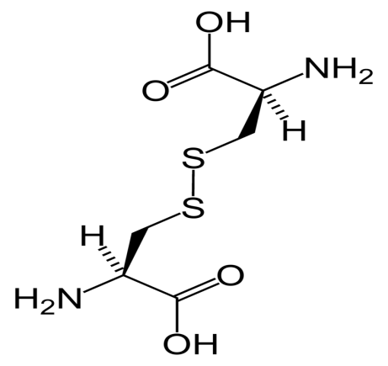
Cystine is the oxidized dimer form of the amino acid cysteine and has formula (SCH₂CH (NH₂) CO₂H)₂ . It is a white solid that is slightly soluble in water. It serves two biological functions, a site of redox reactions and a mechanical linkage that allows proteins to retain their 3-dimensional structure.
Dimer is a chemical structure formed from two similar sub-units.
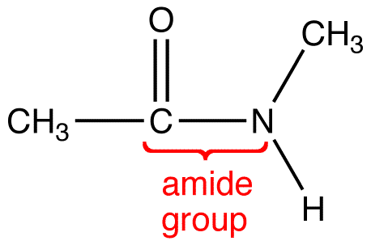
Amide group=amide is an organic functional group characterized by a carbonyl group linked to a nitrogen atom.
Polar molecule when the arrangement of the atoms is such that one end of the molecule has a positive electrical charge and the other end has a negative charge. A polar molecule forms when an atom of high electronegativity bonds with a less electronegative atom. A polar molecule has electrical poles.
Polymerization any process in which relatively small molecules, called monomers, combine chemically to produce a very large chain like or network molecule, called a polymer.
A biogenic amine: They are basic nitrogenous compounds formed mainly by decarboxylation of amino acids. Monoamines (also known as "biogenic amines") include three classes of neurotransmitters:
- Catecholamines : Dopamine (DA), norepinephrine (NE, also called noradrenaline) and epinephrine (E, also called adrenaline)
- Serotonin and Melatonin.
- Histamine has been recognized as a neurotransmitter in the CNS, as well as a pro-inflammatory signal released from mast cells in response to allergic reactions or tissue damage. Histamine is also an important stimulant of HCl secretion by the stomach through histamine H2 receptors.

A biopolymer is a polymer produced by a living organism.

Bond lengths have traditionally been expressed in Ångstrom units, but picometers are sometimes preferred (1 Å = 10-10 m = 100 pm). Bonds lengths are typically in the range of 1-2 Å, or 100-200 pm.
(Source: Boundless. “Bond Lengths.” Boundless Chemistry Boundless, 02 Jun. 2016. Retrieved 21 Mar. 2017 )

